Supportive documents for the promotion of gender equity:

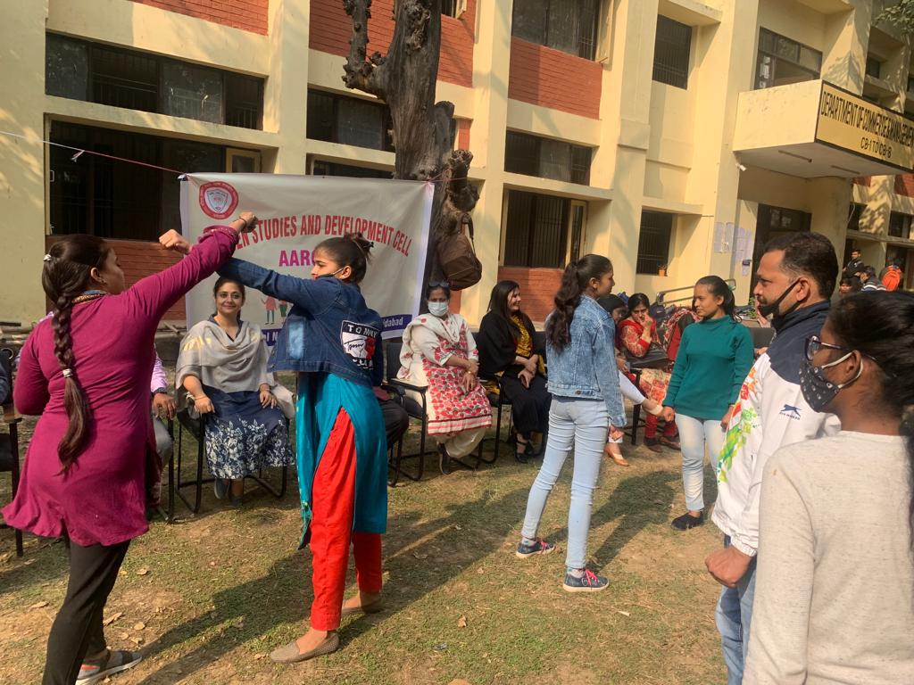
Self Defense Training
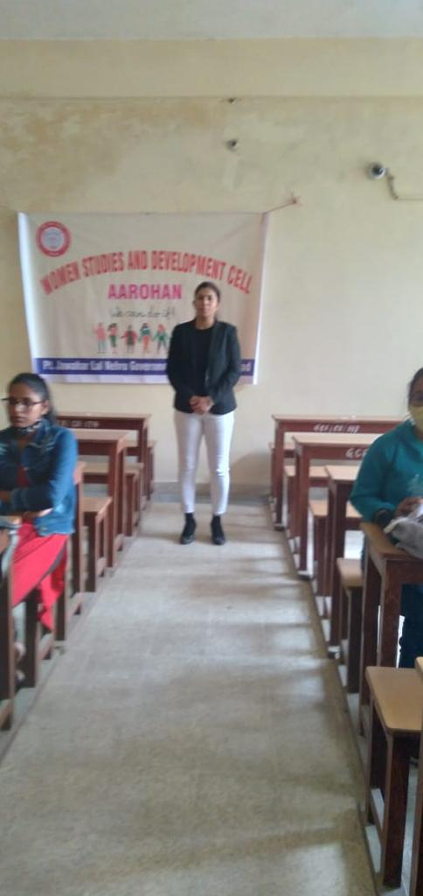
Lecture on Women Empowerment

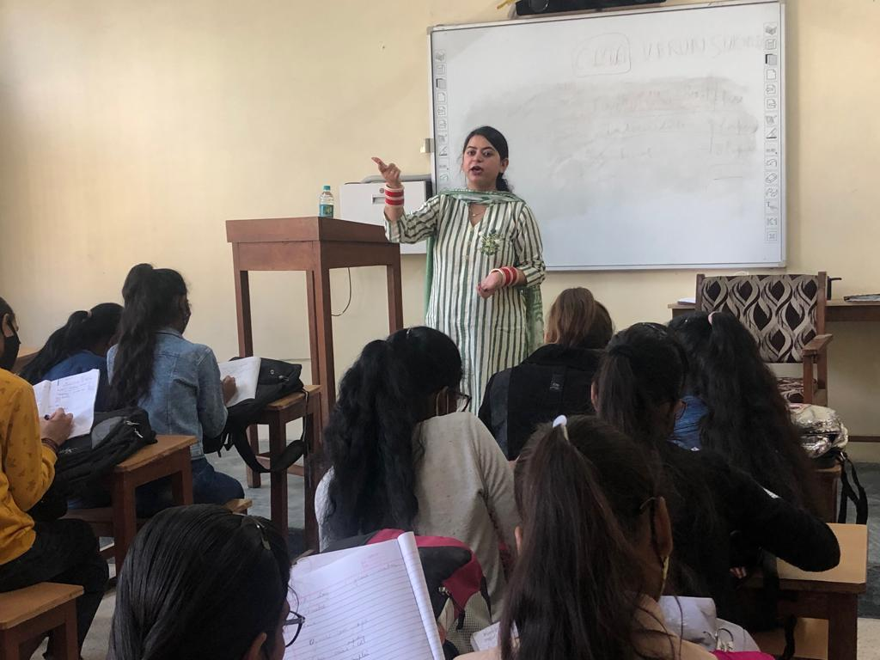
Lecture on Women Rights and Safety

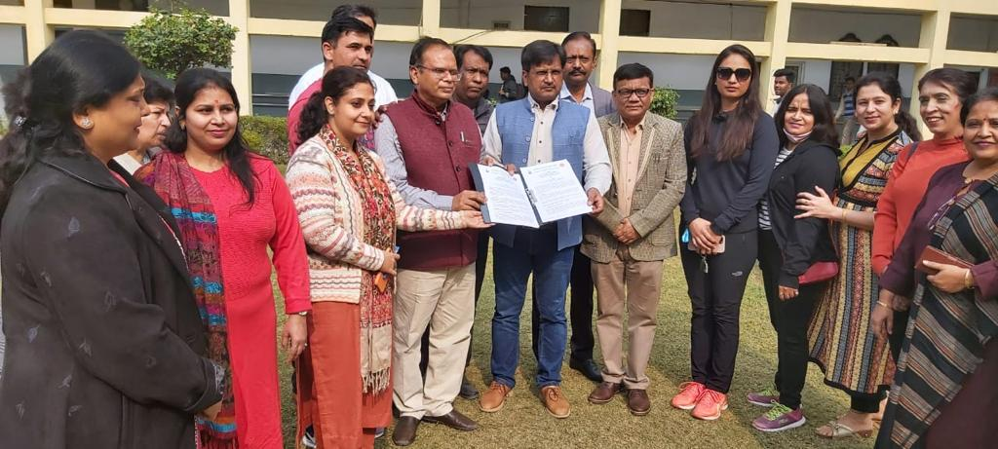
Mou Between Govt. College Faridabad And Haryana Kickboxing Association
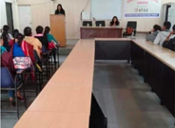
Lecture on Gender Sensitization

