Below are the photographs of different activities along with their Captions:
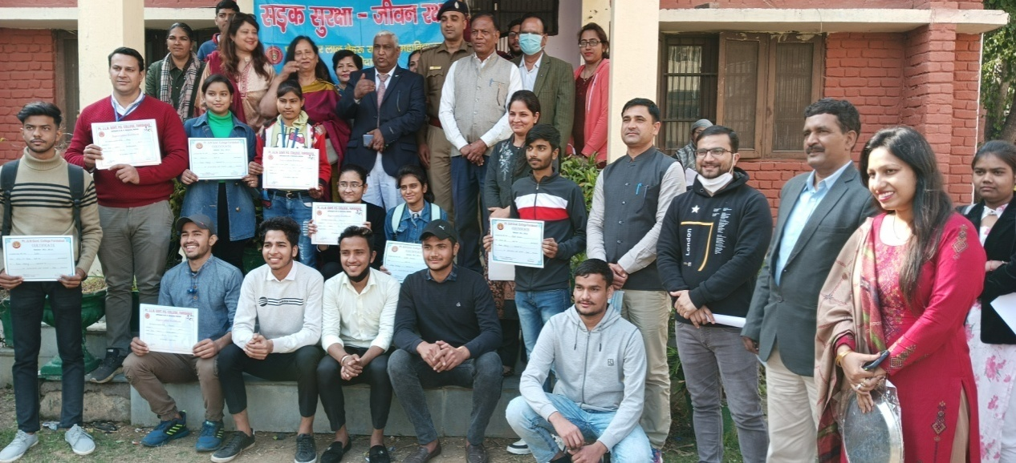

District youth Conference on “Participation of Youth in Nation Building”

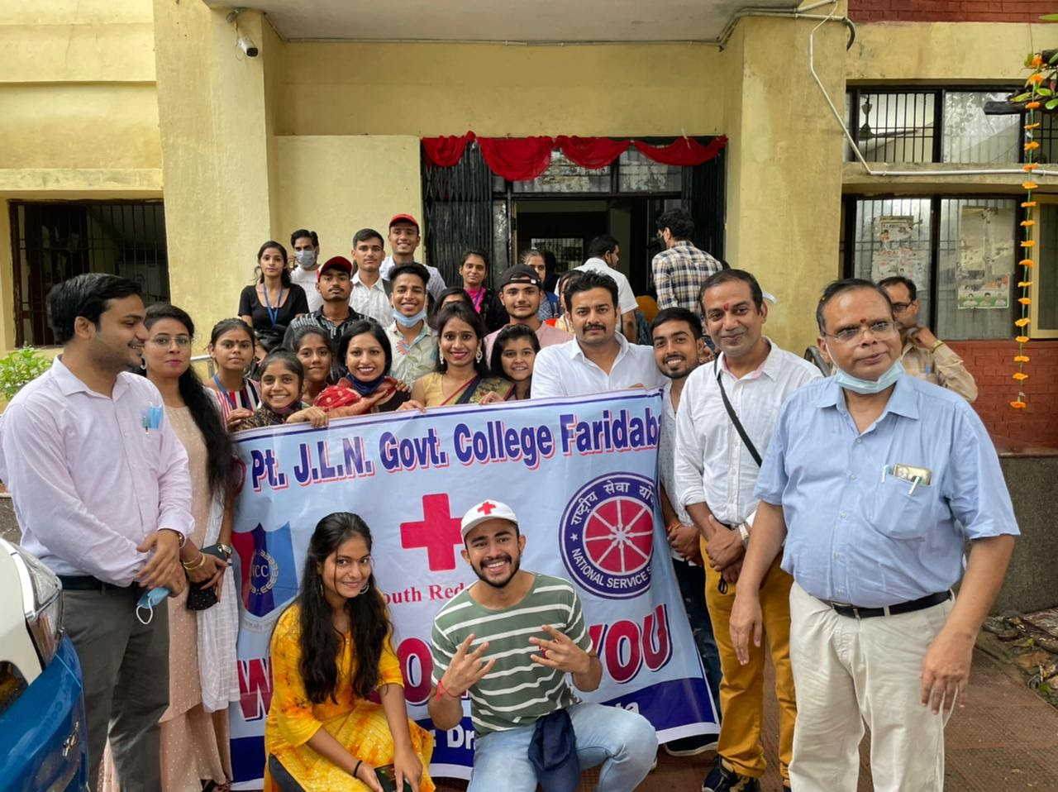
Covid Vaccination Camp
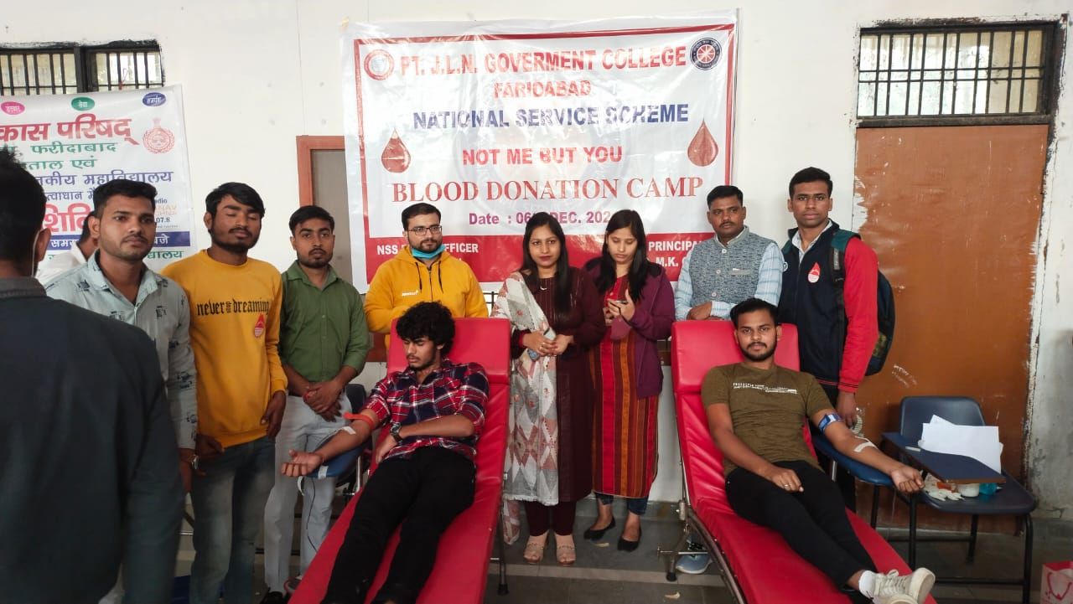
Blood Donation Camp

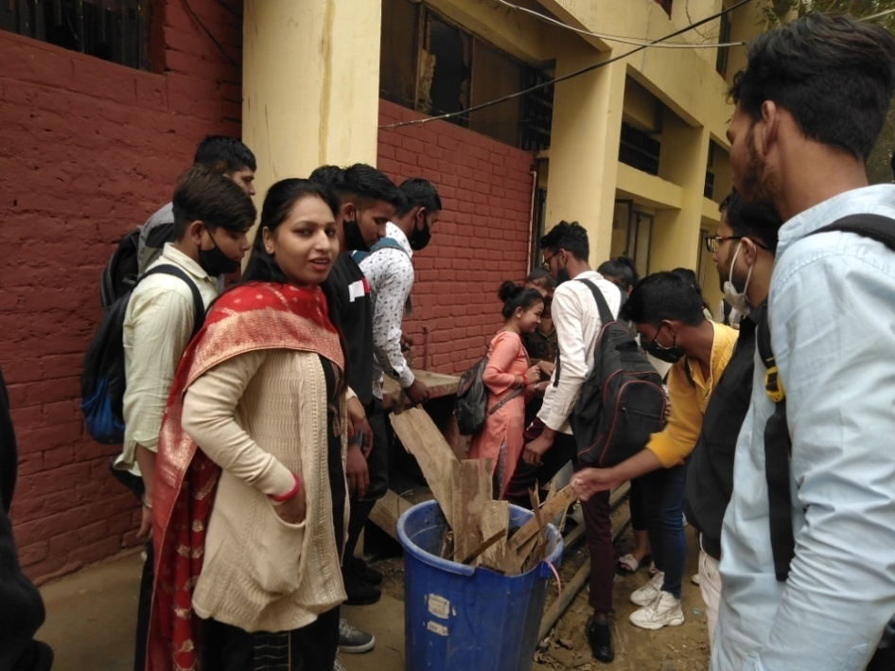
Swachha Bharat Abhiyan
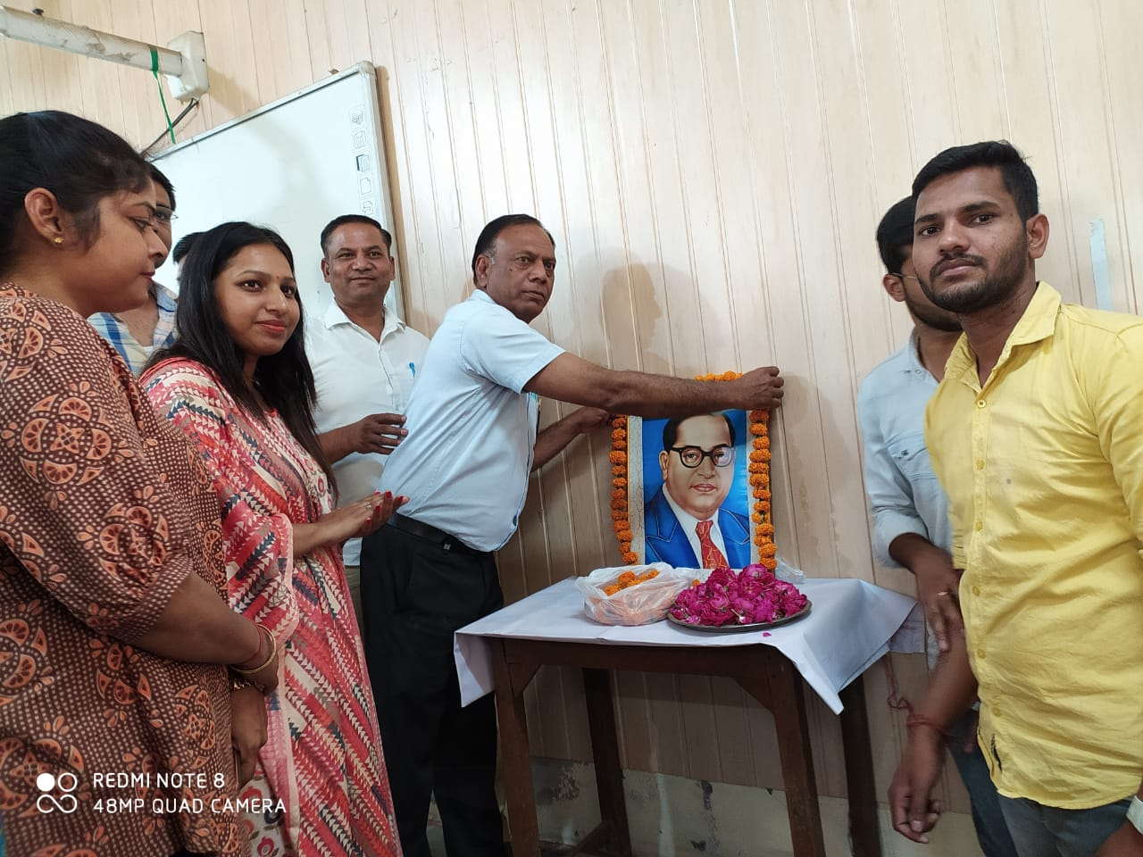
Celebration of Ambedkar Jayanti

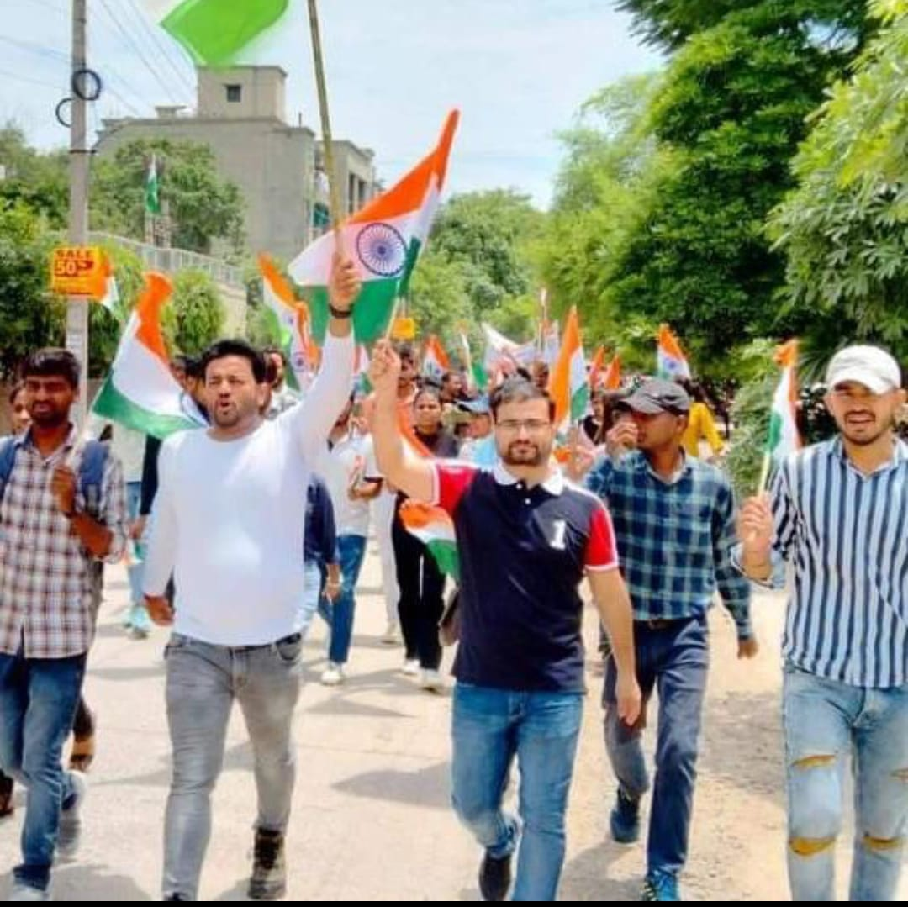
Celebration of Independence Day

