An extension lecture on the topic of Health and hygiene was conducted in the college under women cell by Ms. Ruchi Virmani .She talked about health related issues and benefits of good hygiene responsible for overall good health for the benefits of girl students .

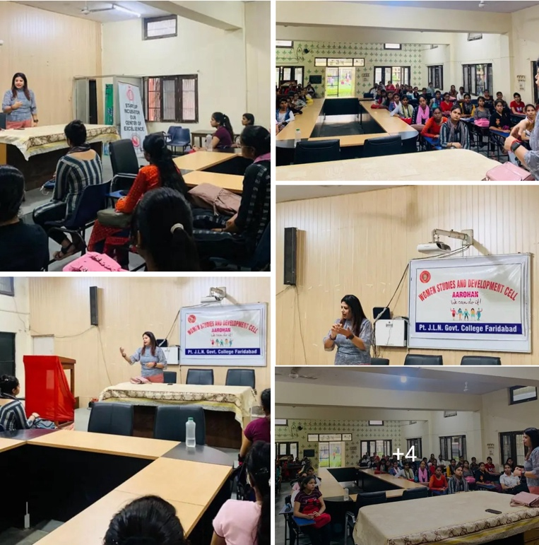
Women cell of our college organised various activities today like essay competition, slogan writing, poster making and speech . The topic for the competition was ‘women empowerment is equal to powerful nation ‘Boys and girls participated with great enthusiasm.
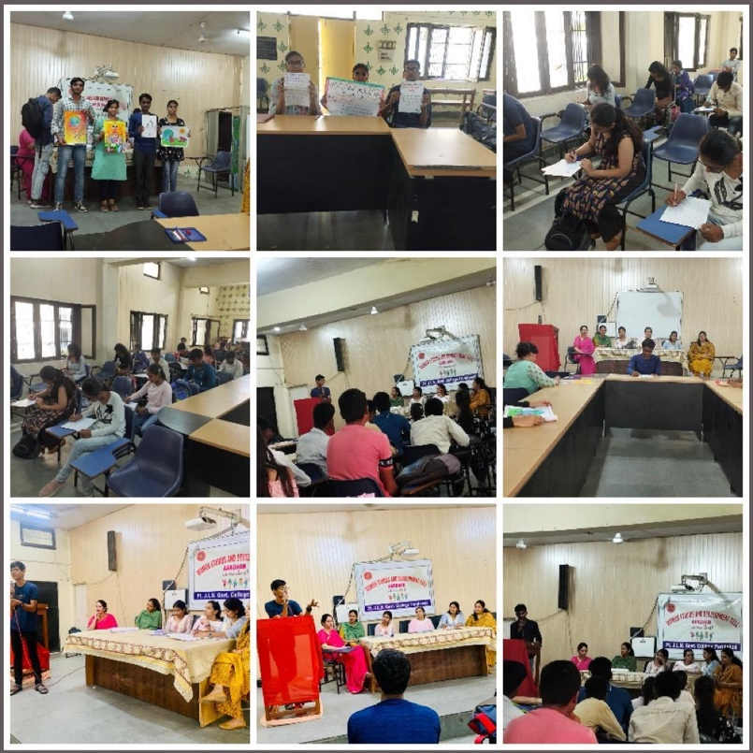
- Under the able guidance of our worthy Principal Dr. M. K. Gupta , A workshop cum training session on the topic of ‘Stand up against street harassment ‘was organised by Women cell of the college in collaboration with Breakthrough organisation and Haryana Police .The workshop was held to motivate students to respond whenever they witness any kind of harassment against women .Ms.Charu Midha ,Convenor Women cell introduced the trainers and presented brief concept of the workshop.

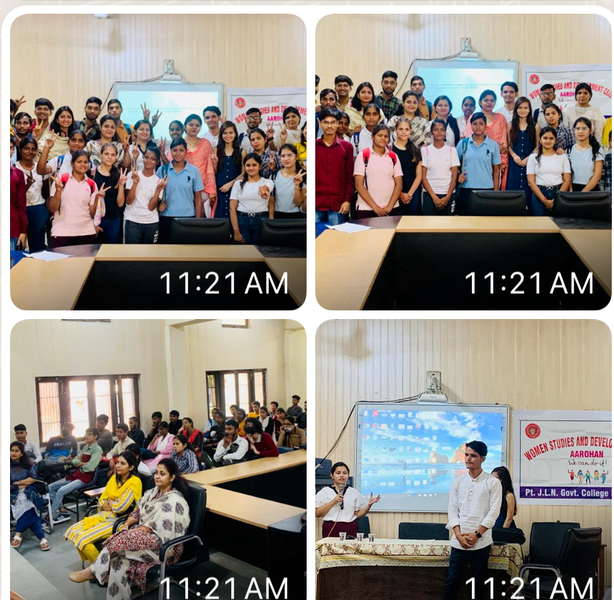
Haryana Kickboxing Association for providing the 40 days training of self defence to girls students of the college .
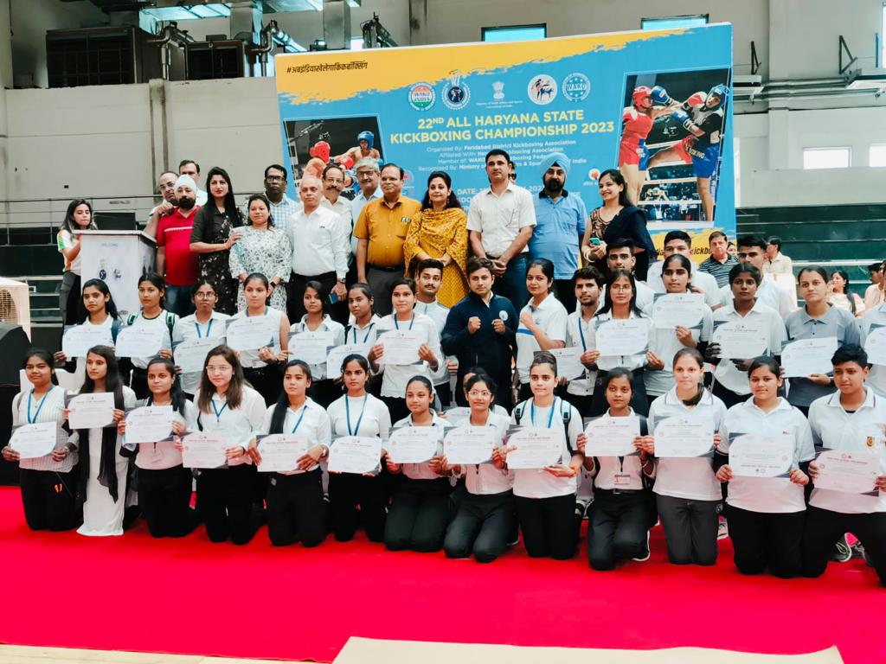

GIRLS COMMOM ROOM For safety of girl’s students, a Girls common room has been prepared in Pt. JLN govt. college, Faridabad which has been furnished by Sanitary Napkin machine.

