

**NAVAL WING NCC**

**PT JLN GOVT COLLEGE FARIDABAD**

**Activities Under Naval Wing Ncc**

**Naval Wing Ncc has performed many activities during academic year**

**2023-2024**

**1:> 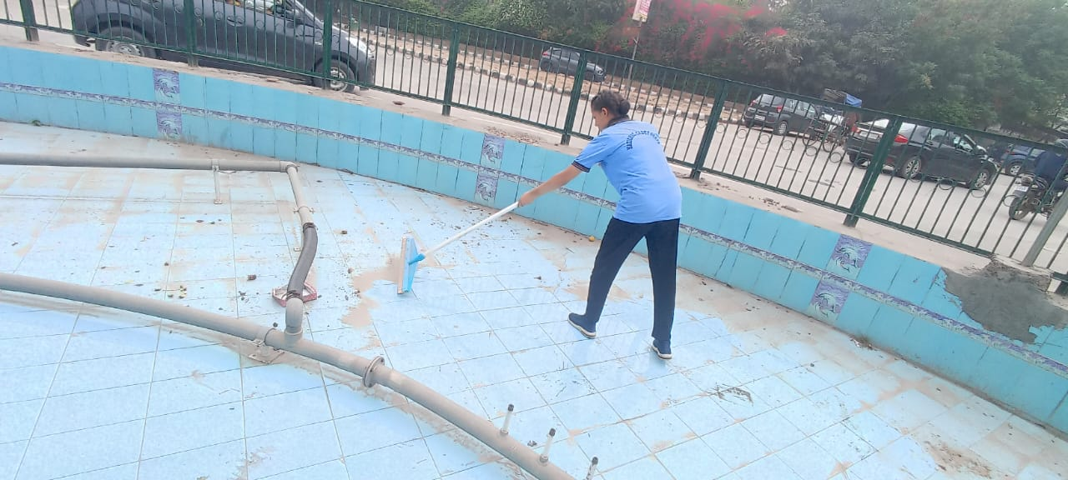Statue cleaning Activity:- 21-03-2023** 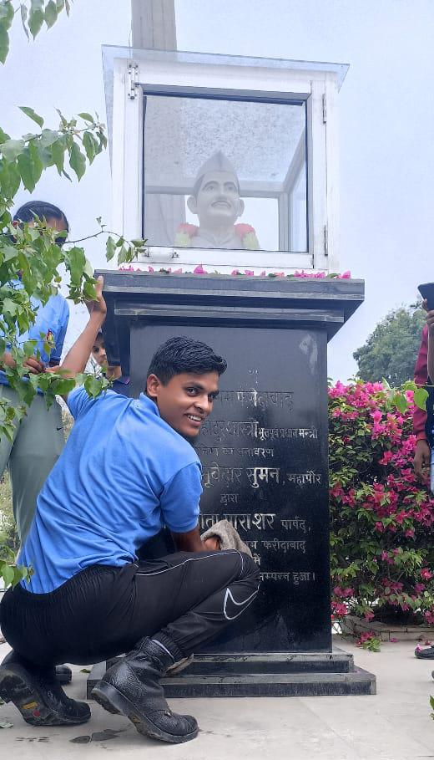Statue cleaning Activity is a part of NCC activity in which Cadets have to clean famous statue in the city. By this campaign, Cadets of Naval wing done a great work to clean the LAL BHADUR SASTRI STATUE near sector 15 Faridabad.

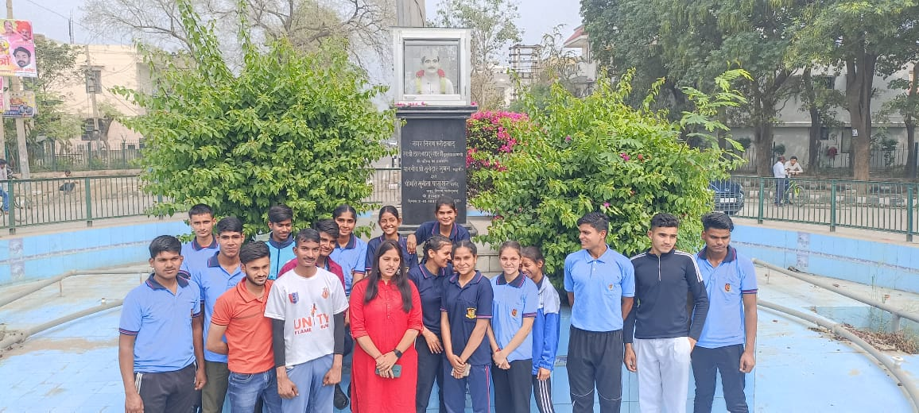This activity was performed under the presence of ANO **DR. AMRITA SHREE .** She guide & motivates cadets to do such type activities in their life. They also said that it shows Patriotism to our nation.

**2:> CATC- 105**

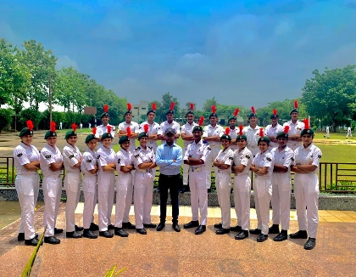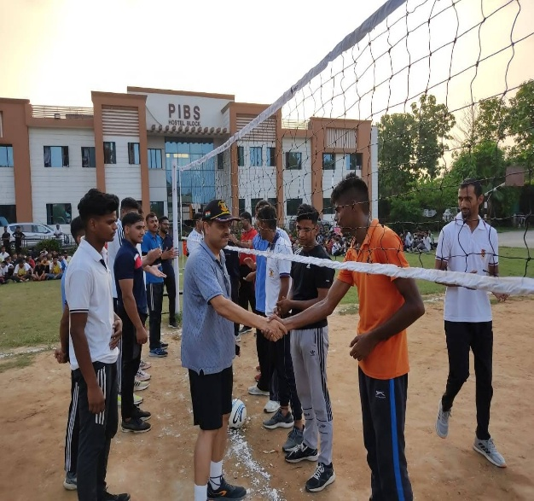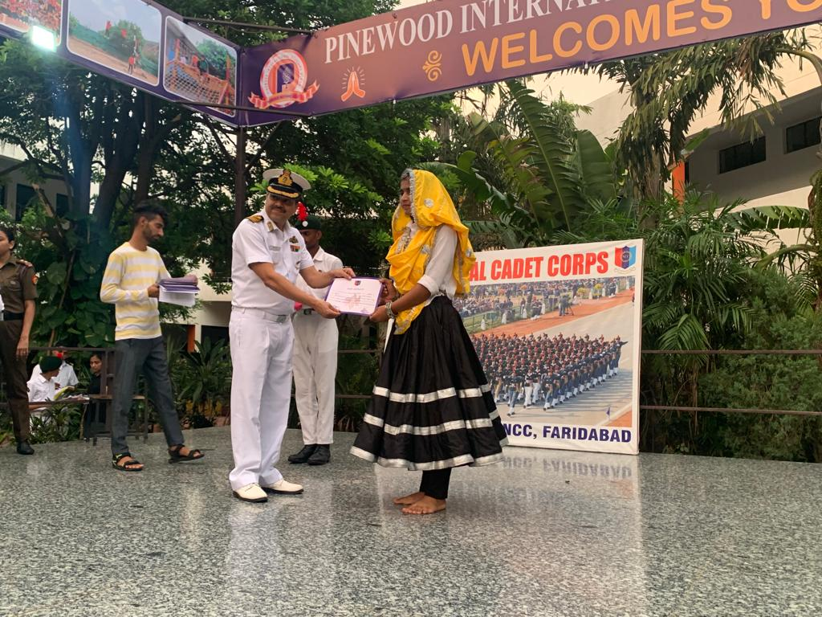Annual training camp is the most important camp in Naval Wing Ncc. It was held from 21june to 30june 2023 at Pinewood international school Faridabad.

This Camp was organised by 1 HR NAVAL UNIT NCC FARIDABAD. During the camp Cadets were trained both physically and mentally.

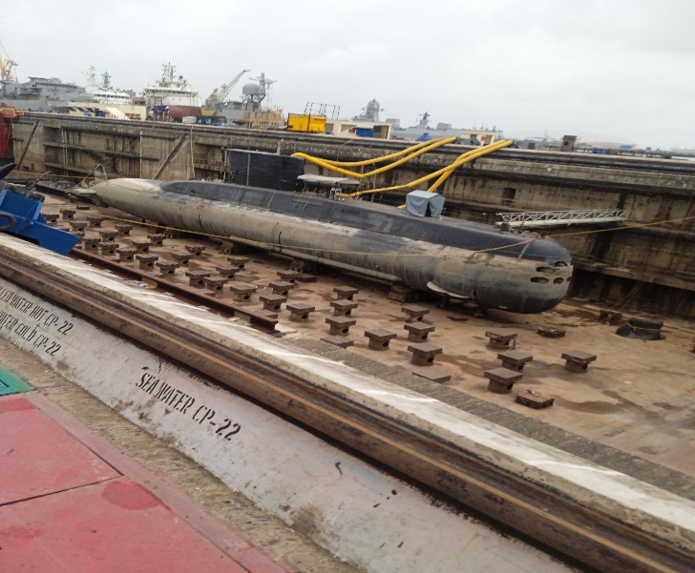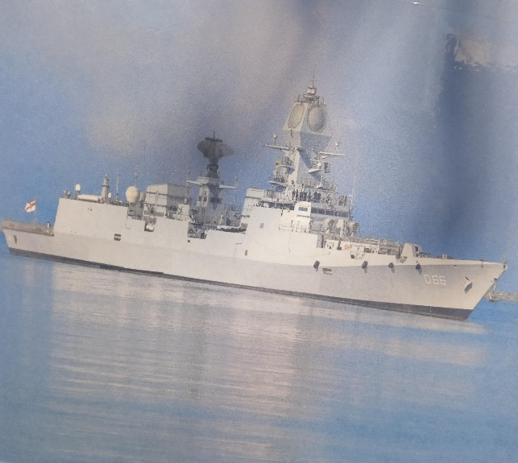**3:> All India Sea Attachment camp Mumbai 2023**

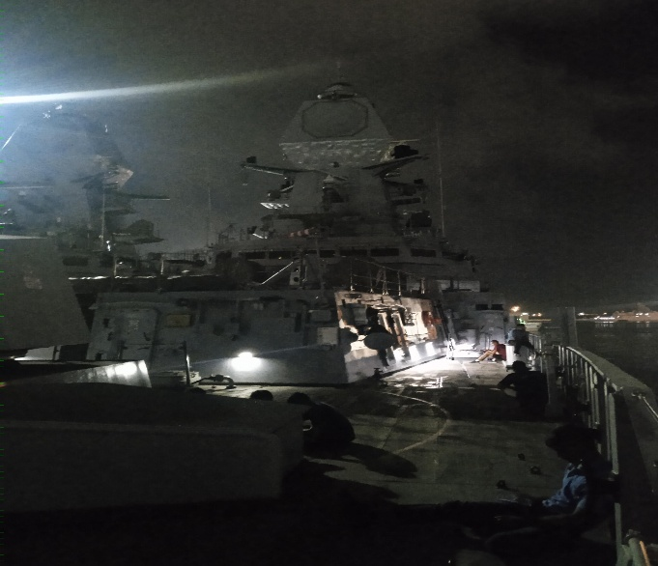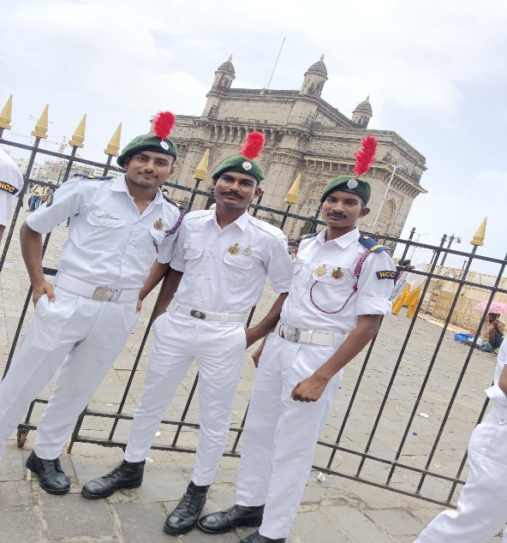All India Sea Attachment camp is an adventure camp where Cdts get attached with **Ship & Submarine** of Indian Navy. This camp was held in Mumbai on 03july to 14july 2023.

**4:> Water conservation competition**

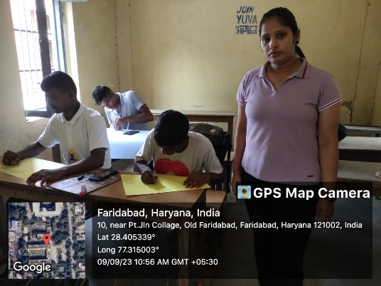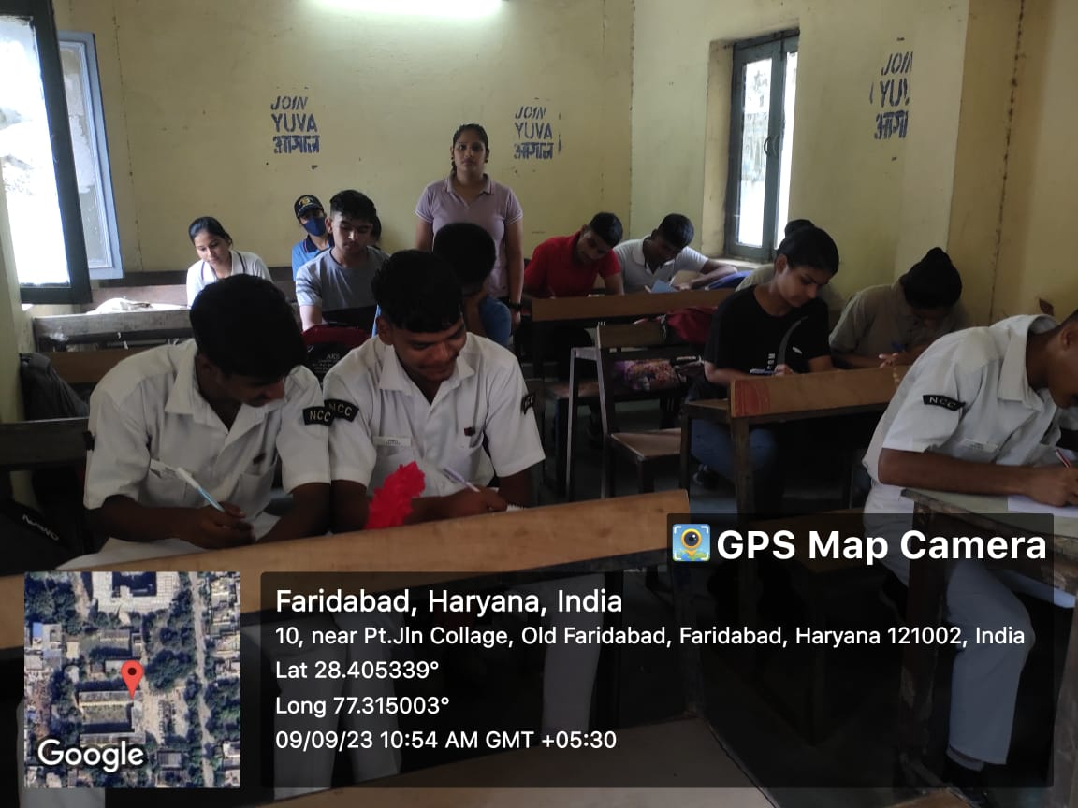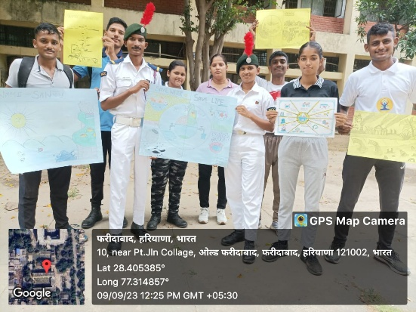Under the puneet Sagar abhiyan Essay writing, poster making competition were organised by college ncc cdts on 9 September 2023.

**5:> SWACHHTA HI SEVA COMPETITION**

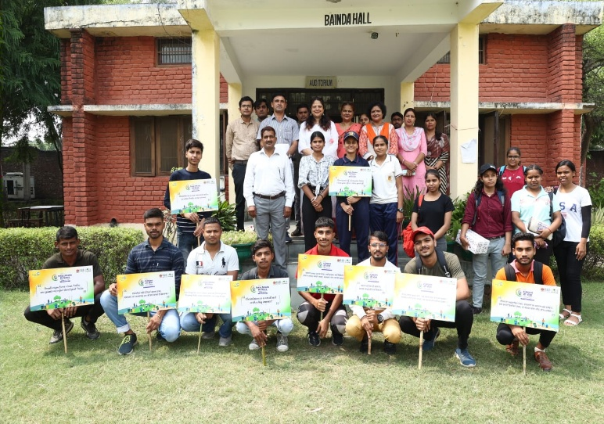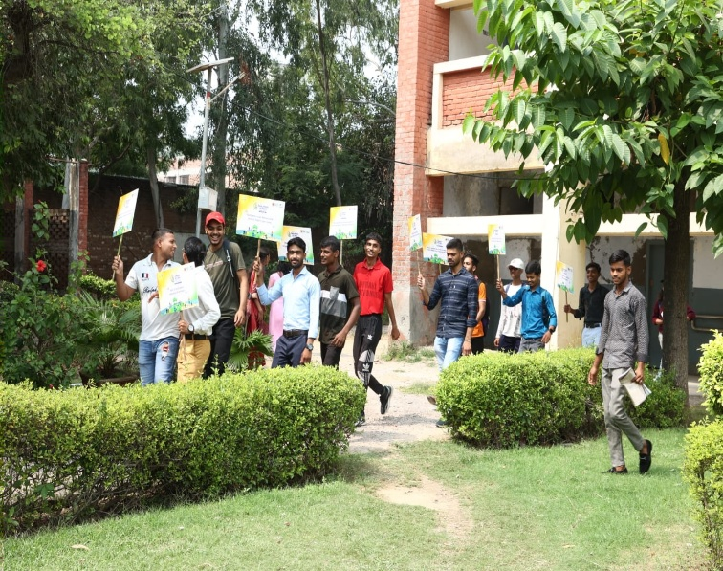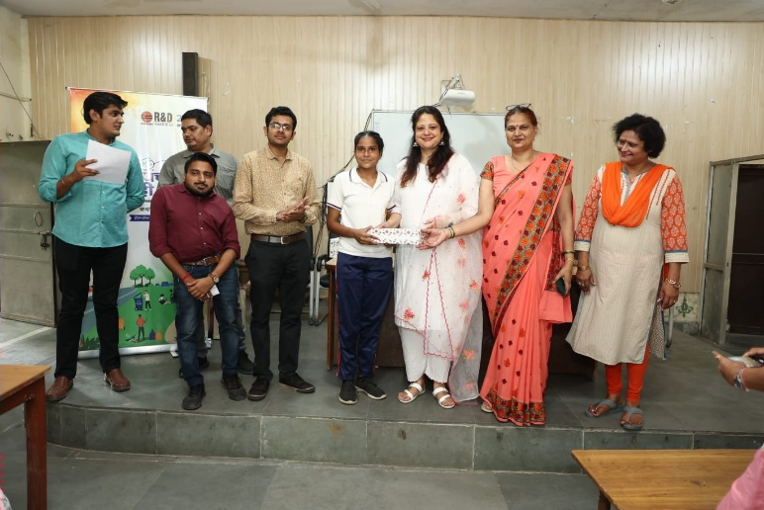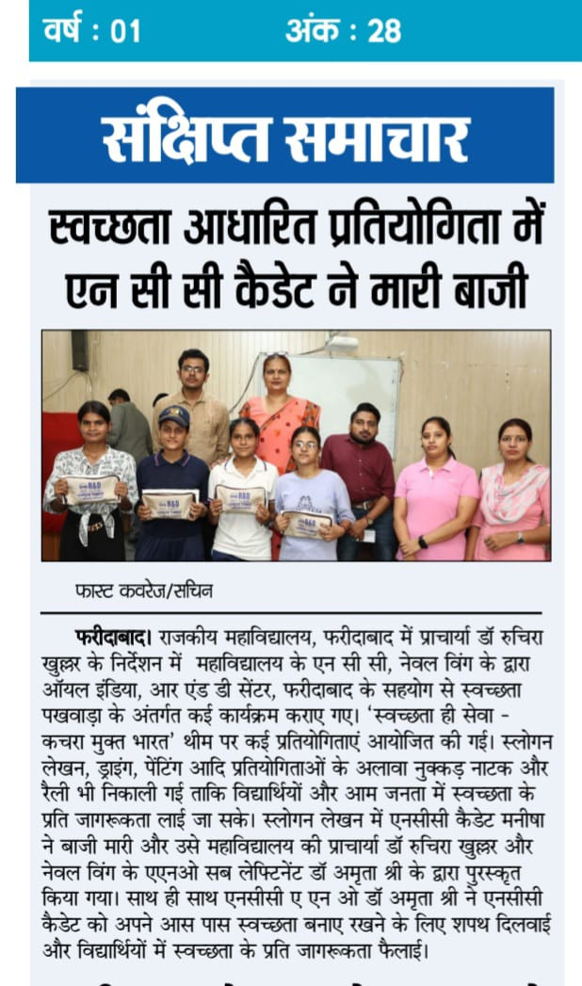Under Swachhta Pakhwada , Awareness Rally was conducted in the college Dated **01.10.2023.**The motto of this rally was to aware students to maintain the college campus clean . On the occasion **ANO Slt. Dr. Amrita shree, College principal Dr.Ruchira khullar mam** present and motivate the students

**6:> National women’s day**

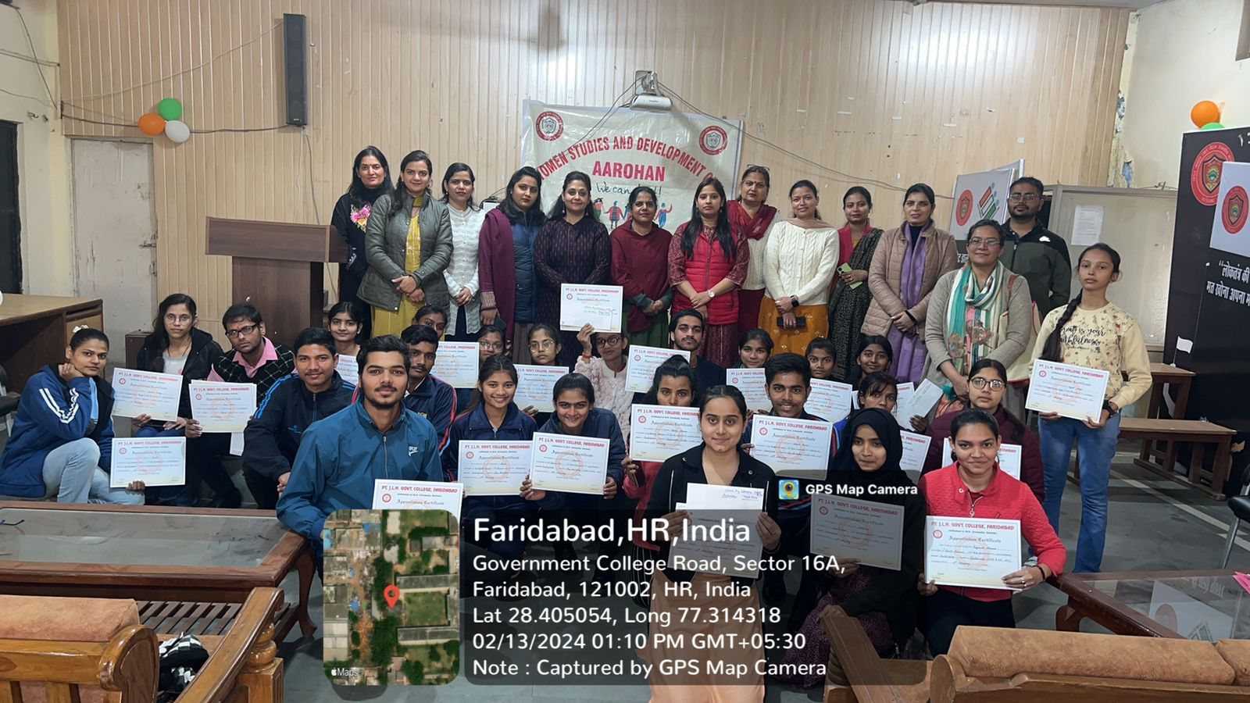13th February, National Women’s Day was celebrated in Government College, Faridabad. Various competitions were organized on the occasion of National Women’s Day under the patronage of College Principal Dr. Ruchira Khullar and under the direction of NCC, Naval Wing’s ANO Sub Lieutenant Dr. Amrita Shree and Women Cell in-charge Dr. Charu Midha. Underlining the importance of National Women’s Day, Dr. Amrita Shri said that this day is celebrated on the occasion of the birth anniversary of Sarojini Naidu. Dr. Charu Midha inspired the students to participate in such competitions. To empower women, poetry recitation competition, speech competition and debate competition were organised. Students participated enthusiastically in these competitions and expressed their views through the above competitions. The program was conducted by Dr. Amrita Shri and Dr. Renu Yadav. The jury of these competitions included Mrs. Meenakshi Rawat, Dr. Anshu Bhatt, Mr. Amit Kumar and declared the results of the competitions with their keen discretion. The winners of the competitions were students Aman Sharma, Nancy, Vanshika, Lakshita, Anuradha and Sakina. Other professors of the college also contributed in the successful organization of these competitions, including Dr. Ankita, Dr. Kanchan Zameer, Mrs. Savita, Dr. Ramnik, Mrs. Deepika etc.

**7:> IYOM 14-10-2023**

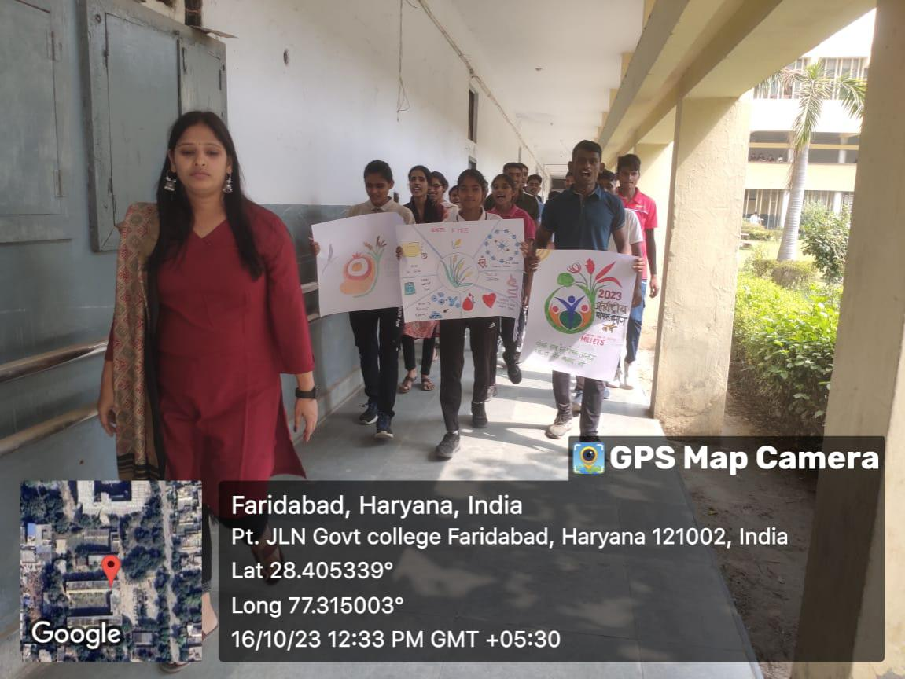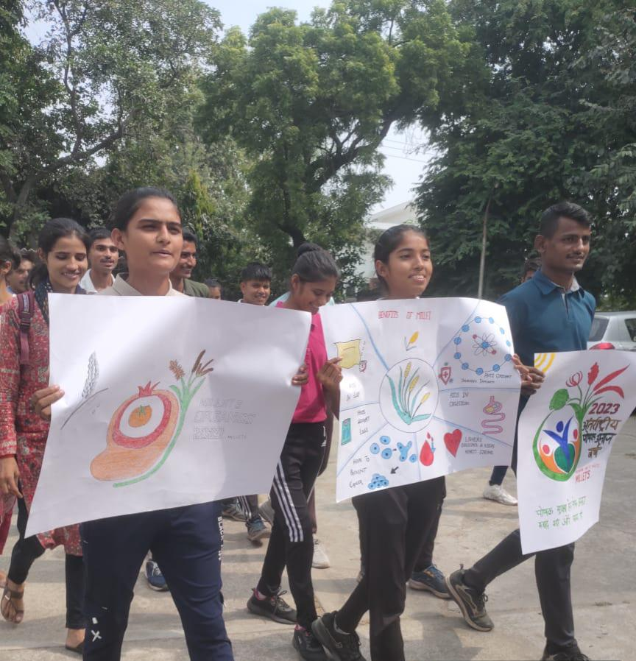Under the CAMPAIGN BY MINISTRIES/DEPARTMENTS FOR INTERNATIONAL YEAR OF MILLETS 2023, Cadets of our college organised a rally & poster making competition to spread awareness people about values of millets in our life.

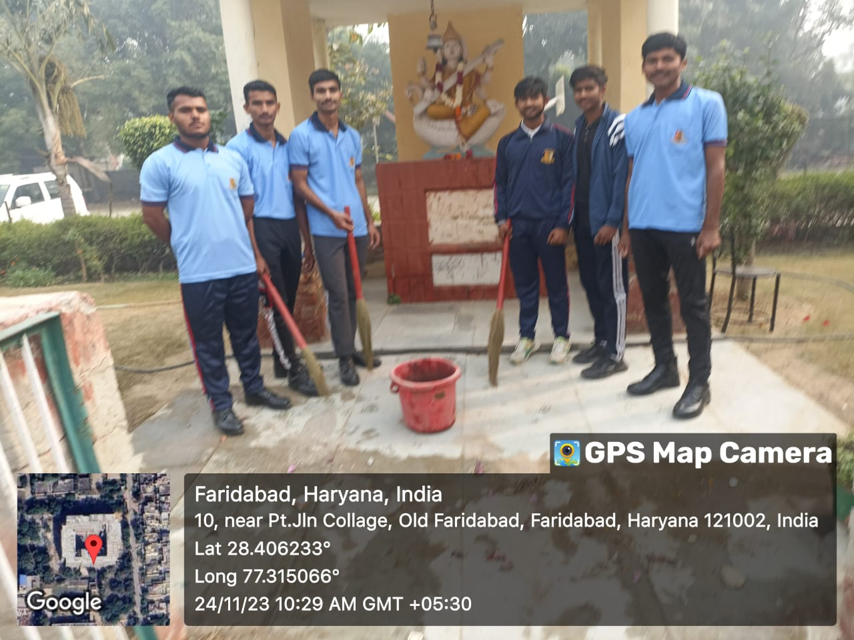**8:> Statue cleaning activity November 2023**

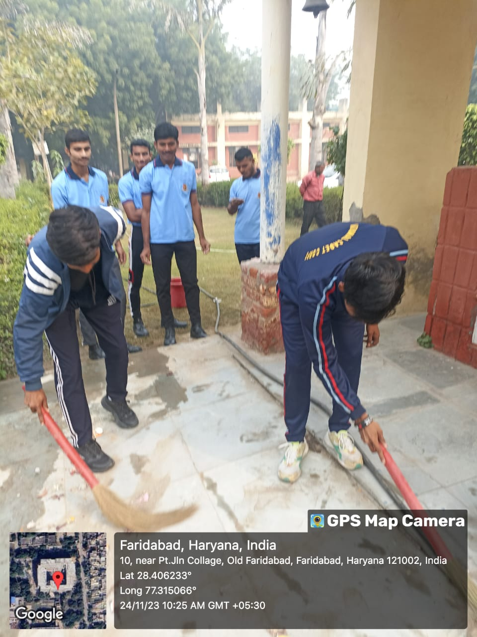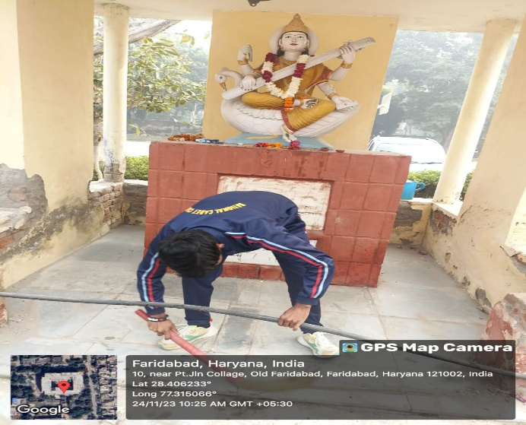Cleaning of famous statue is an important activity under Synergy youth program of NCC. Every month cdts participates in it .

**9:> Ullas 2024**

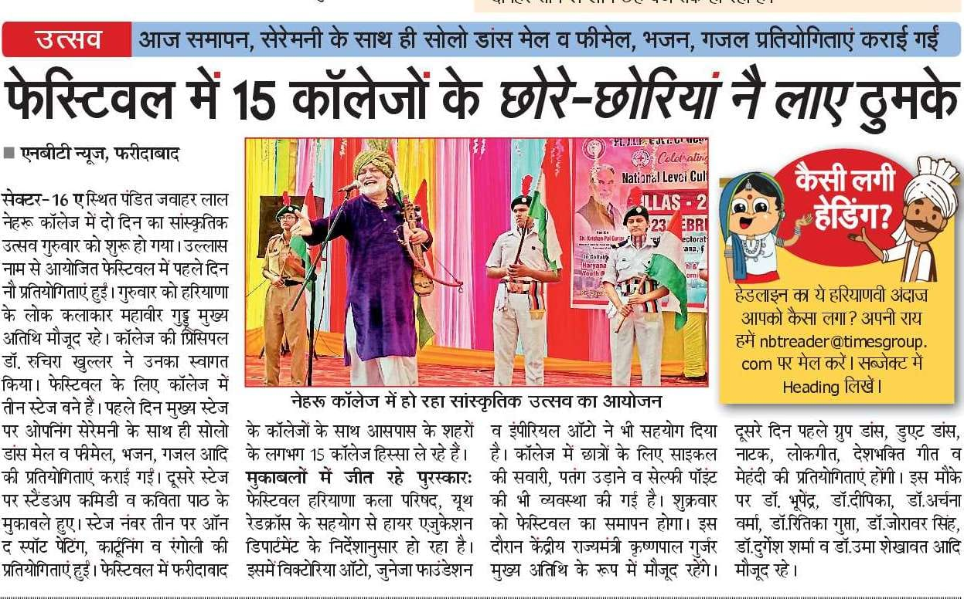Cultural festival Ullas was celebrated in college on 22-23 Feb 2024 under Higher education department Haryana. Chief guest if festival were Haryana Lok Kalakar Mr. Mahaveer Guddu & Haryanvi Singer Seema choudhary.