On 4th September 2023, Women Cell of J.L.N. Govt. College organized Camp for Anaemia check-up for Girl Students under direction of Principal Dr. Ruchira Khullar. DC. Faridabad Shri Vikram Singh closely monitored the anaemia check-up of girl.
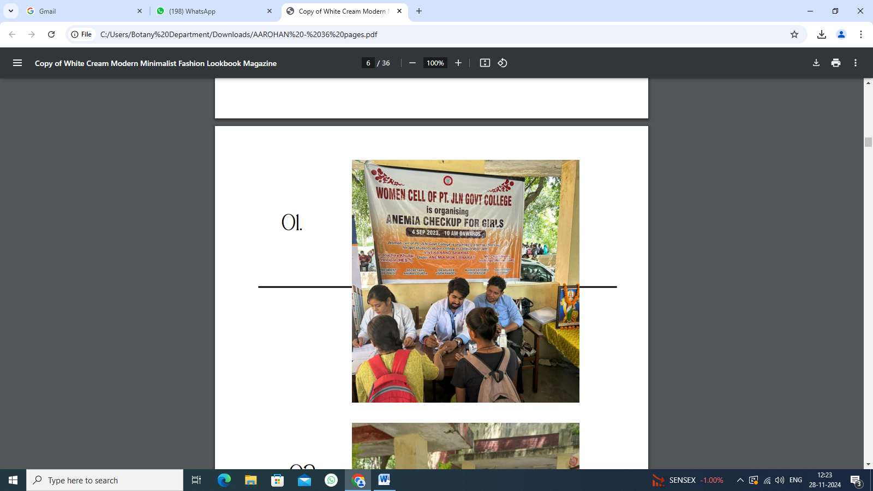
ON 12th October 2023, Seven students (girls) from J.L.N. Govt. College Faridabad participated in 'Cyclothon' organised by "Haryana Rajya Mahila Aayog' for the cause ; Drug free Haryana. Cyclothon which was from sector 15 market to Sector -12 stadium. Girls were provided -shirt and cap from Mahila aayog who marched on cycle to create awarness for Drug De-addiction to make Haryana Drug Free

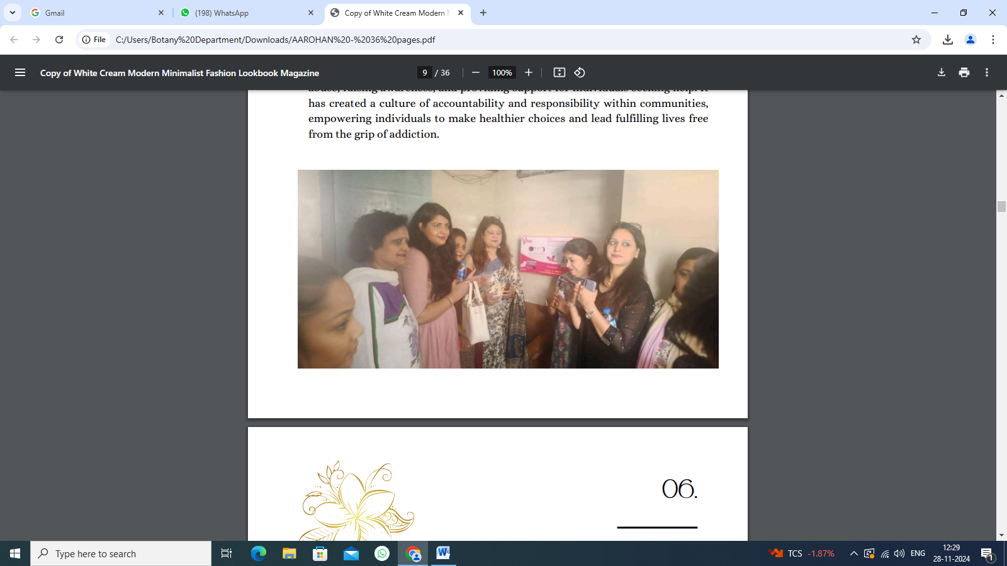
On 31st october 2023, A 3-day cooking workshop was organized under the women's cell under the guidance of Principal Dr. Ruchira Khullar, Dr. Charu Midha, The program coordinator (women's cell in charge) along with Dr. Lalita Chaudhary and Dr. Ankita played pivotal role in ensuring the program's success. Enthusiastically 35 students participated in the workshop, where they were introduced to 'millet' recipes and received a nutrition on Lecture from dietician Priyanka Pawar.

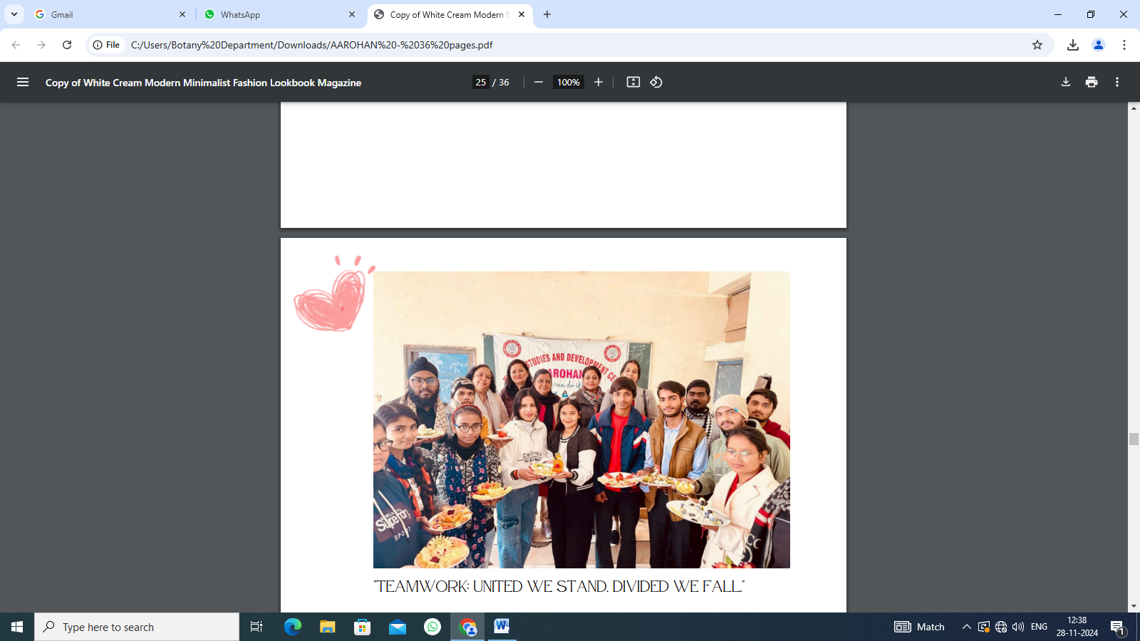

International Women Summit being organized by the Haryana State Commission for Women on the occasion of Silver Jubilee foundation Day of the Commission on 12th January 2024 at 1100 AM in Raj Hans Resorts Faridabad, Haryana
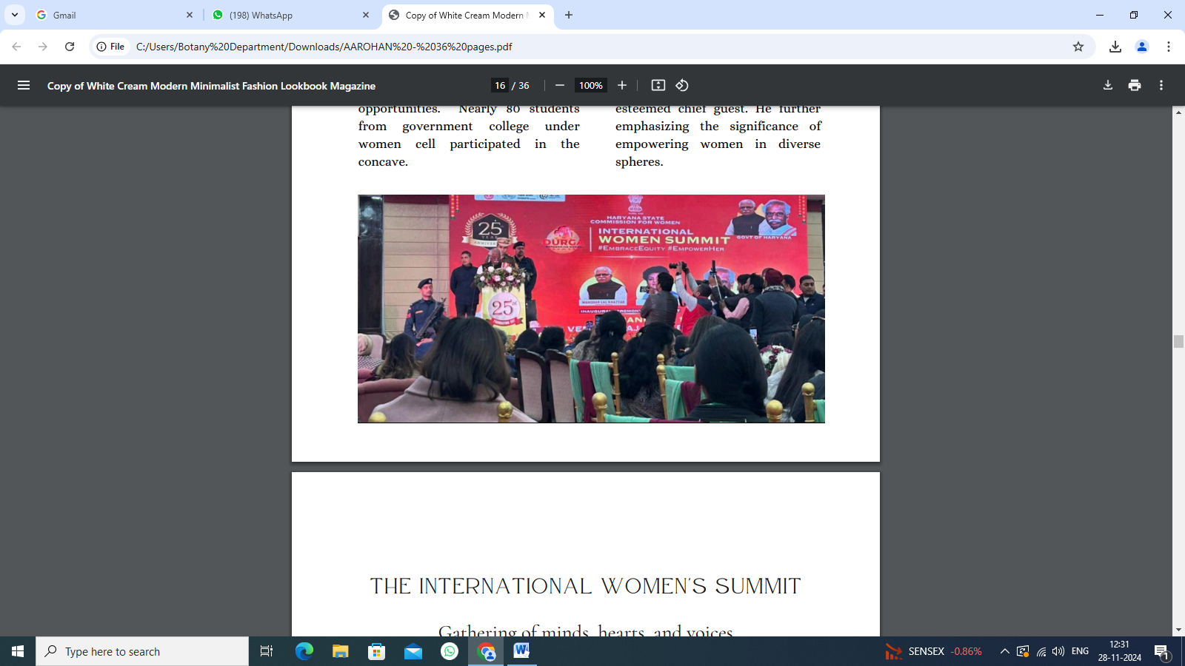

On 31st january2024, The 'Best out of Waste Competition, organised by the women's cell under Principal Dr. Ruchira Khuller's guidance on January 31,2024 at Government College, Faridabad was a success.
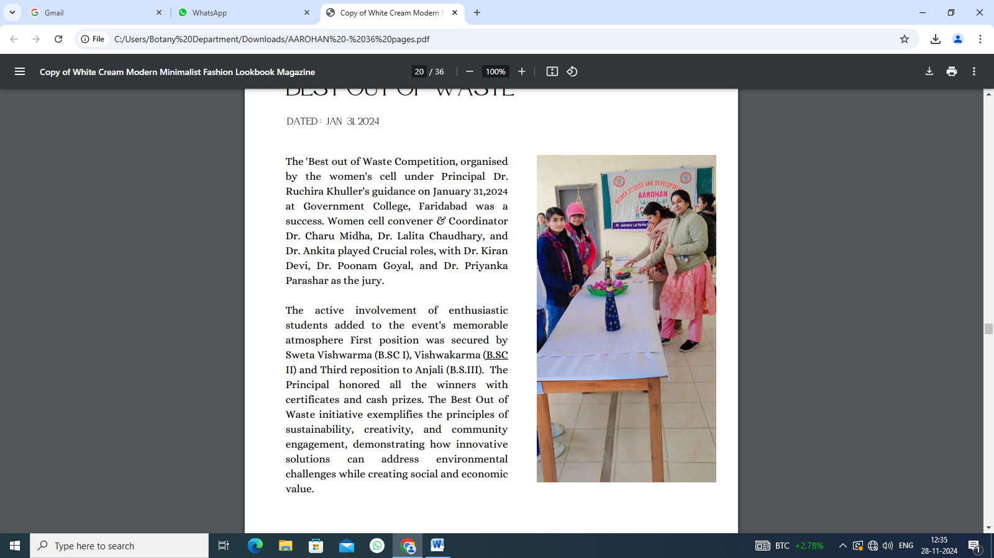

On 6th Feb 2024, Under the able guidance of Principal Dr. Ruchira Khullar and Convenor of Women's Cell, Dr. Charu Middha, J.L.N. Government College hosted a seminar on "Stress Management and Creating Happiness," facilitated by Mr. Mahesh Bajaj, a renowned expert in the field of mental health and well-being on Feb 06, 2024. The seminar aimed to equip participants with practical strategies for effectively managing stress and fostering happiness in their personal and professional lives.

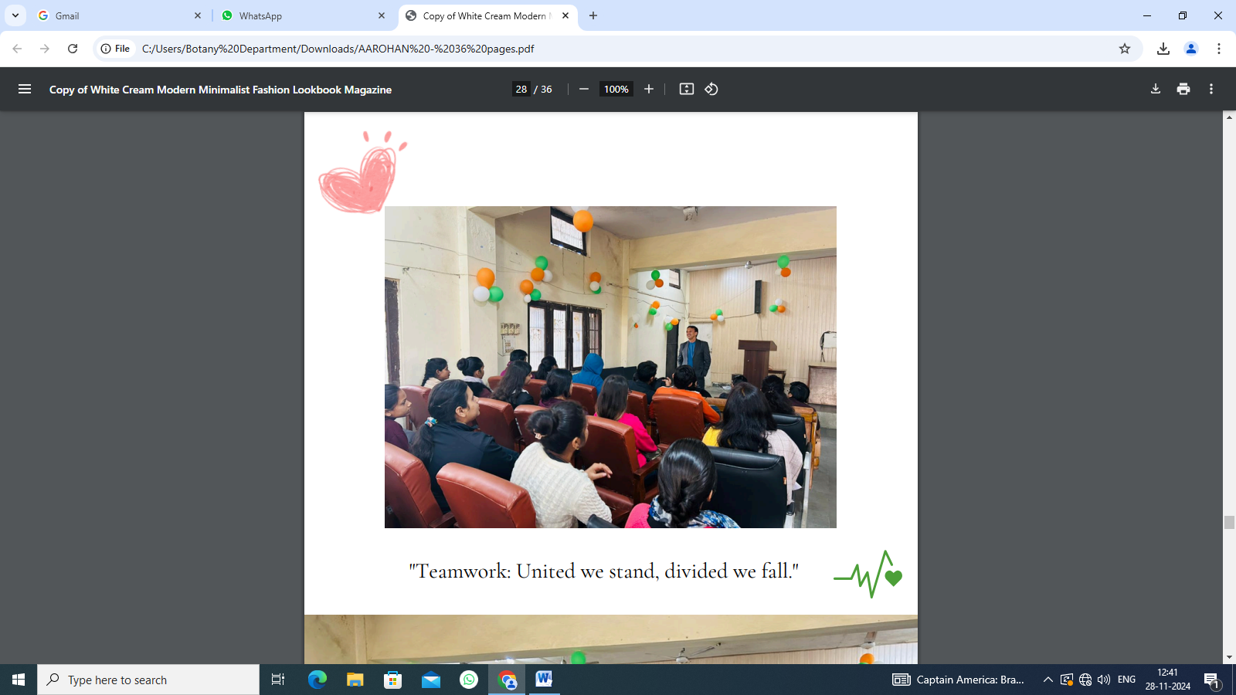
On 12th Feb 2024, A Three - day Personality Development to was organized by the women's cell 15.2.2024 at J.L.N. College Faridabad under able guidance of Principal Ruchira Khullar. Aim was to enhance the Personality of students and improve their confidence and prepare them for future. The Training was given by Ms. Meenakshi Kaul to the students of the College. She covered various topics like Interview Techniques, personality development and time management.

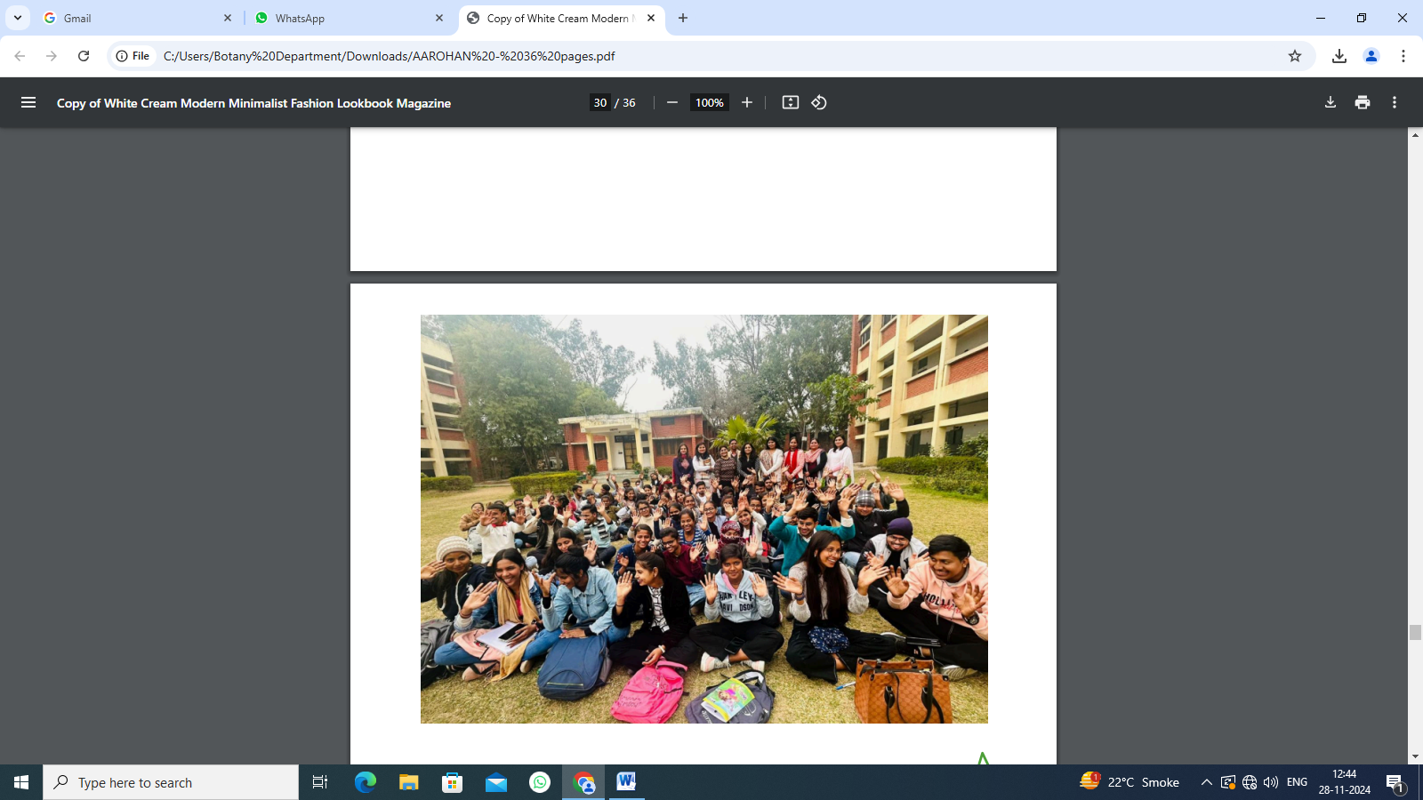

On 13th February 2024, An awareness session on Polycystic Ovary Syndrome (PCOS), Polystic Ovary Disorder (PCOD) and Menstrual Hygiene was organized by the Women's cell for female students of J.L.N. college Faridabad under direction of convener Dr. Charu Midha. and Dr. Indu Taneja, a renowned gynecologist, conducted the session, ensuring it was both interactive and informative

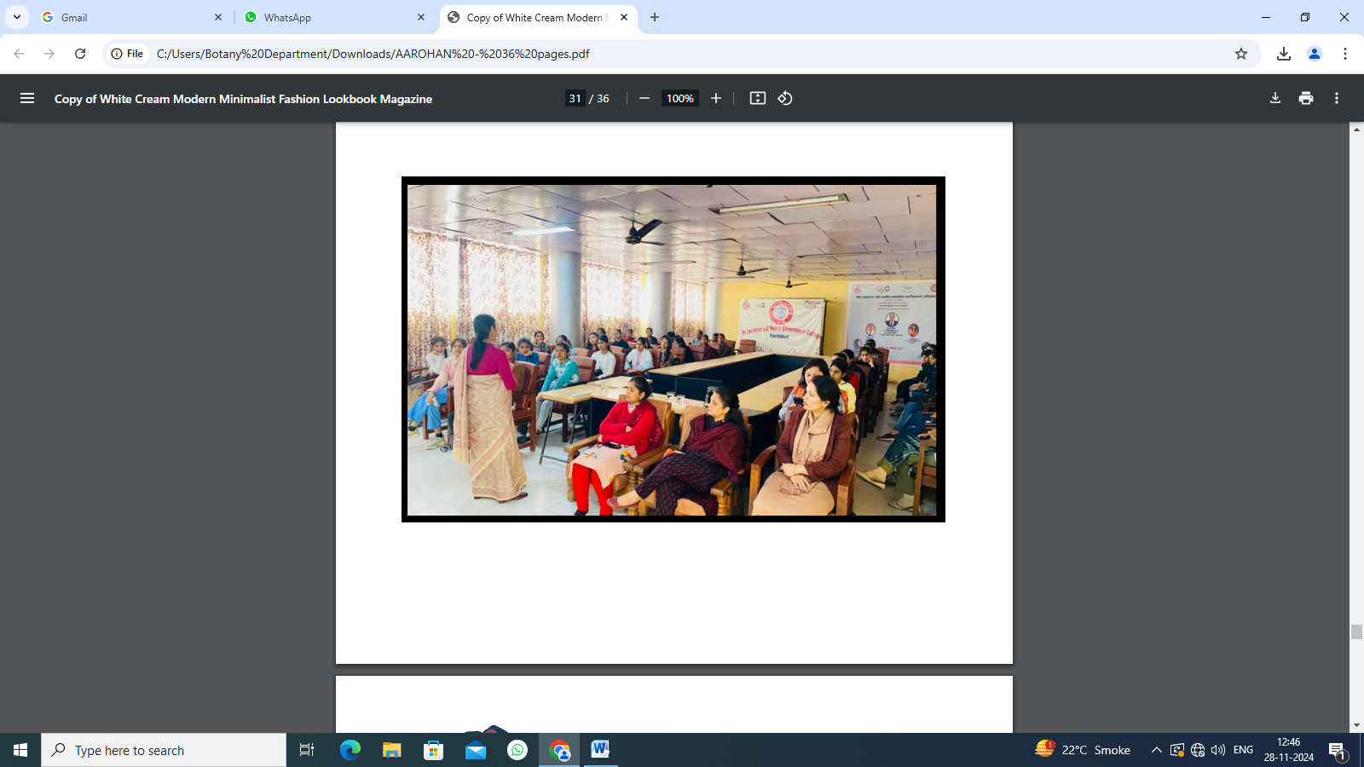

National Women day was celebrated on 13.2.2024 under guidance of Principal Ruchira Khullar. Competitions were held by women cell in collaboration with NCC (Naval wing). Debate was on topic, "Is women's empowerment a myth in developing Countries". Declamation was on "Women in India (c) 2047. and Poem Recitation on "women and Society"

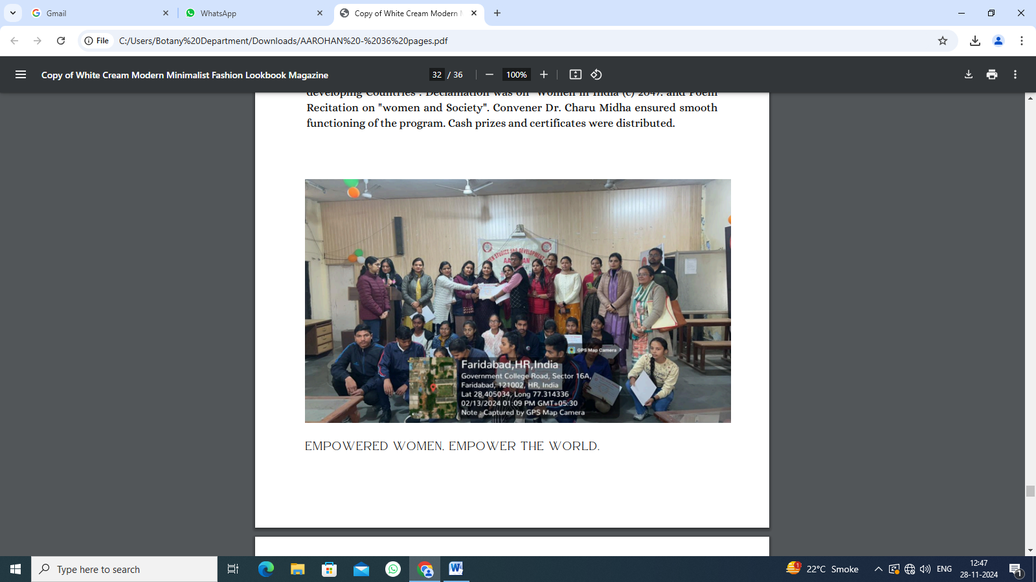

On 9th March,2024 Dr. Ruchira Khullar and Dr. Charu Middha led the Women's Cell in organizing a gender sensitization speech competition on International Women's Day at J.L.N. Government College. Over twenty students participated, with Prachi, Vikash, and Akash winning the top positions. Gender sensitization: A catalyst for profound change. It challenges norms, fosters empathy, and champions equality. It's not just about awareness; it's about transforming hearts and minds, paving the way for a more inclusive world where everyone's worth is honoured, regardless of gender.

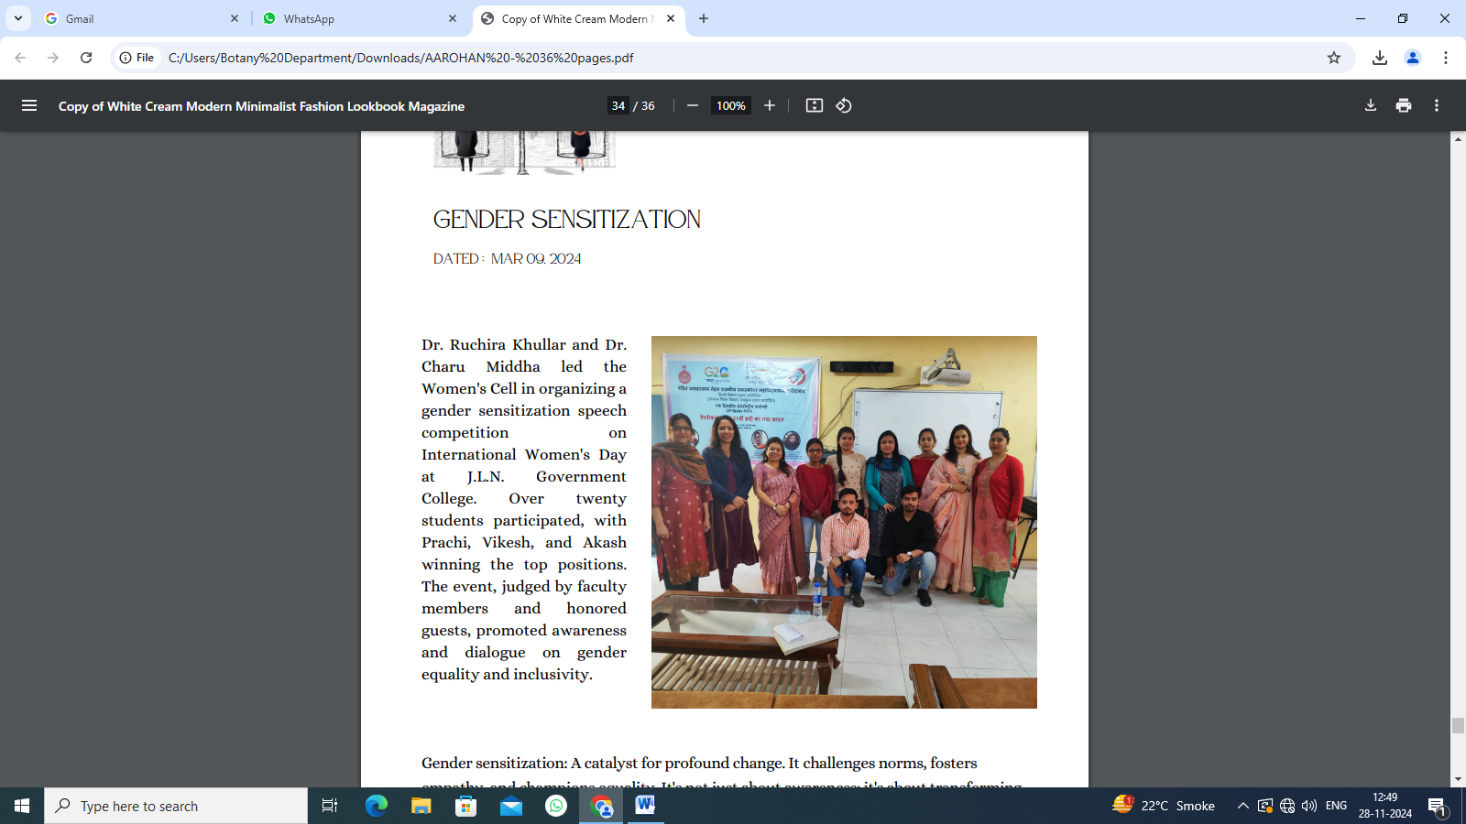

GRIEVANCE AND REDRESSAL COMMITTEE FOR FEMALE STAFF AND STUDENTS for addressing grievances of girls and woman’s staff, women’s redressal committee was formed by Pt. JLN Govt. College, Faridabad.
GIRLS COMMOM ROOM For safety of girl’s students, a Girls common room has been prepared in Pt. JLN govt. college, Faridabad which has been furnished by Sanitary Napkin machine.

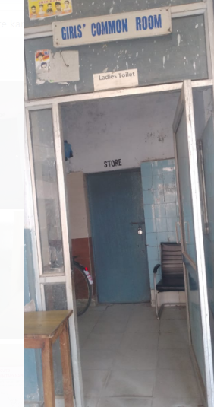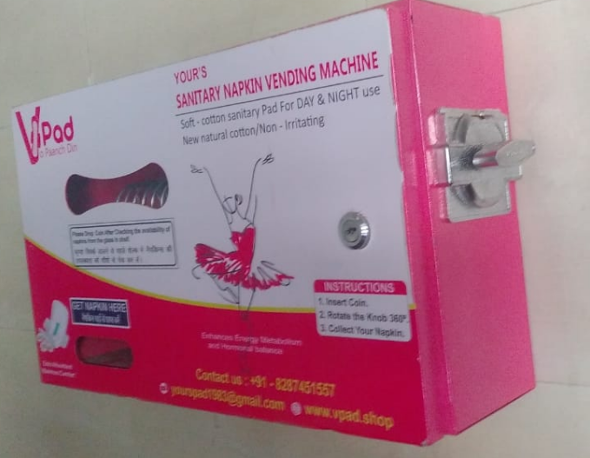

NAAC 7.1.9
On 8th July 2023, pt. JLN govt. college, NSS cell organise two days cleanliness camp to make students to understand importance of cleanliness and environment.

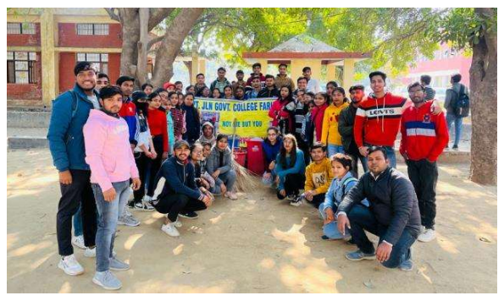
On 8TH August 2023, pt. JLN govt. college, NSS cell organise rally for awareness about importance of voting to make them a responsible citizen.

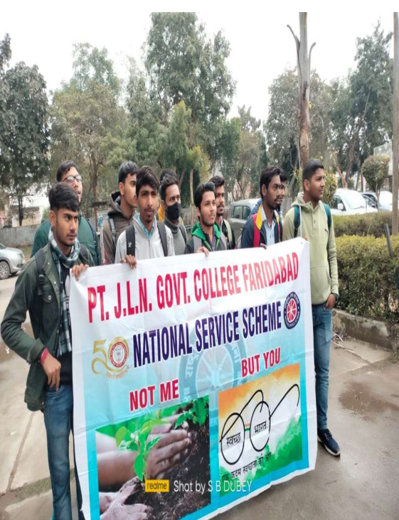
On 17th September 2023, pt. JLN govt. college, NSS cell organise a blood Donation camp .

On 6th November 2023 NSS cell organized a rally on importance of De-addiction to make students to understand the importance of de-addiction and how it is important to our society.
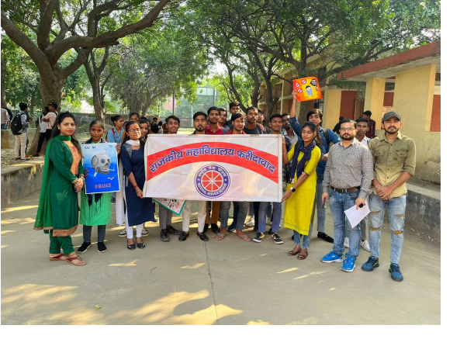

Under the able guidance of Dr. Ruchira Khullar, Principal Pt. J.L.N. Govt. College, Faridabad, college level competitions under Legal Literacy Cell - Essay Writing, Poetic Recitation, Debate, Declamation, Skit, Quiz, On the Spot Painting, Slogan were conducted on 04.03.24. PPT and Documentary competitions were organized on 06.04.24.
