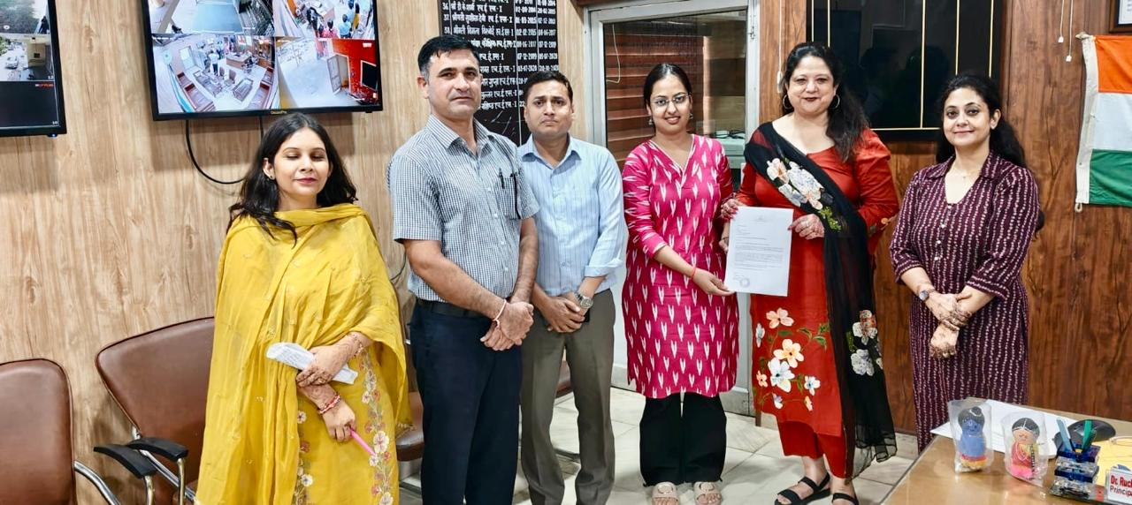

Empowering Her Future: , Pt. JLN Govt College , Faridabad ✍️ Nimaya Foundation

We are proud to announce the MoU between Women cell of Pt. JLN Govt College Faridabad and Nimaya Foundation — a commitment to open doors and shape brighter career journeys for our girl students.

Under this partnership, our young women will gain access to Nimaya’s career-accelerator programme, which equips them with 21st-century workplace skills, soft skills, mentorship, and placement support.
We are confident this collaboration will strengthen their confidence, broaden opportunities, and help them step confidently into meaningful jobs.

Together, we will transform potential into success — because every girl here deserves the tools and support to dream big, aim high, and achieve.

